EXAM NUMBER:

Year 10
English
Yearly Examination
SECTION 1 – STIMULUS BOOKLET
2024
Total marks – 20
Pages 1-6
•

Text One – Image
Text Two – Prose Fiction Extract
Text Three – Memoir Extract
Text Four – Poem

General Instructions
- Reading time – 10 minutes
- Working time – 80 minutes for Section I and II
•

- Write using blue or black pen
•

•

Note: Any time you have remaining should be spent revising your answers.

DO NOT REMOVE THIS PAPER FROM THE EXAMINATION ROOM

BLANK PAGE

____________________________________________________________
In your answers you will be assessed on how well you:
- demonstrate understanding of the complexities and insights into the individual human experience within society
- describe, explain and analyse the relationship between language, forms and features
________________________________________________________________________
Text One – Image – New Yorker Magazine Titlepage

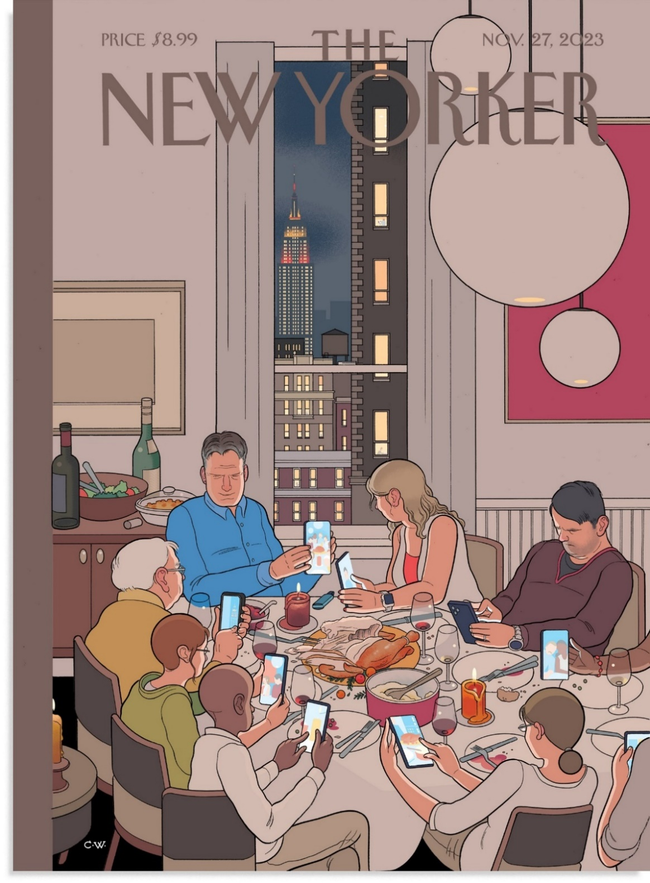
Stimulus booklet continues on page 4
Text Two – Prose Fiction Extract - There Was Still Love by Favel Parett

Ludek felt light-headed with the smell of schnitzels frying golden in the pan. God, Aunty Mana was a good cook. He tried to hide his delight when she cooked for them because it upset Babi. It was the one subject that caused trouble between them. Ludek left it alone. He never asked what was for dinner or who was going to cook. BUT GOD he loved it when Aunty Mana cooked. Even her vegetables tasted good. Even the carrots. Even the cabbage.
Babi said that Aunty Mana was only good because she had worked as a maid in London and she had been taught. ‘No one ever taught me how to cook,’ she said. ‘We had nothing. There wasn’t even anything to cook.’ Aunty Mana never responded when Babi said these things. She just watched her sister, her face serious, her mouth held still. Ludek sat down at the table and Uncle Bill poured him a small glass of beer. Babi gave them both a look, but Ludek picked it up and took a sip anyway. It was like something sour and rotten washing around his mouth. He screwed up his eyes and put the glass down. Everyone laughed. Babi gave him a glass of water and he drank it.
Aunty Mana put a schnitzel on his plate, some fried potato, and a big scoop of cucumber and cream salad. Ludek watched the cream flood the plate. That was the best thing – the taste of the cream salad mixed with the potato, the cream melting into the crispy schnitzel crumbs. It was all of his favourite foods on one plate and he could barely contain himself. The very second Uncle Bill began to eat, he inhaled his first mouthful.
Uncle Bill had a system. He ate everything evenly so that each different food on his plate disappeared at the same rate. This included whatever he was drinking. There was never more of one thing than another, and his last mouthful always included a bit of everything. Ludek had tried to copy this system a few times, but it was no good. What if you got full and you wasted your belly space eating cabbage? You might have to leave a dumpling behind, and someone else might eat it before you found room again. It was better to eat your favourite food first. All of it. Then your second favourite, and then the rest. Ludek ate his schnitzel first, all of it. The adults got two and he got one and there were no more left.
Ludek had no idea how Babi had gotten so much meat. She was trying her best to get everything for her sister, and the two of them stood in lines and shopped all day, chatting on and on all the while, and Ludek could not stand it if he had to go with them because everything took forever – every shop the same, every line the same – and even if he got a soft drink out of it or an ice-block, it was not worth it. They had run out of toilet paper, and it had been a three-day mission trekking around the streets to try and find some. They had to cut-up newspaper and Uncle Bill said it hurt his arse. He told Ludek it was like going back to ‘the bloody days of rationing.’ Ludek had no idea what that meant. Babi was embarrassed.
Uncle Bill slipped Ludek his last bit of schnitzel, and Ludek scoffed it down.

Stimulus booklet continues on page 5
Text Three – Memoir Extract - Educated by Tara Westover
I’m standing on the red railway car that sits abandoned next to the barn. The wind soars, whipping my hair across my face and pushing a chill down the open neck of my shirt. The gales are strong this close to the mountain, as if the peak itself is exhaling. Down below, the valley is peaceful, undisturbed. Meanwhile our farm dances: the heavy conifer trees sway slowly, while the sagebrush and thistles quiver, bowing before every puff and pocket of air. Behind me a gentle hill slopes upward and stitches itself to the mountain base. If I look up, I can see the dark form of the mountain.
The hill is paved with wild wheat. If the conifers and sagebrush are soloists, the wheat field is a corps de ballet*, each stem following all the rest in bursts of movement, a million ballerinas bending, one after the other, as great gales dent their golden heads. The shape of that dent lasts only a moment, and is as close as anyone gets to seeing wind.
Turning toward our house on the hillside, I see movements of a different kind, tall shadows stiffly pushing through the currents. My brothers are awake, testing the weather. I imagine my mother at the stove, hovering over bran pancakes. I picture my father hunched by the back door, lacing his steel-toed boots and threading his callused hands into welding gloves. On the highway below, the school bus rolls past without stopping.
I am only seven, but I understand that it is this fact, more than any other, that makes my family different: we don’t go to school. Dad worries that the Government will force us to go but it can’t, because it doesn’t know about us. Four of my parents’ seven children don’t have birth certificates. We have no medical records because we were born at home and have never seen a doctor or nurse. We have no school records because we’ve never set foot in a classroom. When I am nine, I will be issued a Delayed Certificate of Birth, but at this moment, according to the state of Idaho and the federal government, I do not exist.
Of course I did exist. I had grown up preparing for the Days of Abomination*, watching for the sun to darken, for the moon to drip as if with blood. I spent my summers bottling peaches and my winters rotating supplies. When the World of Men failed, my family would continue on, unaffected.
*corps de ballet – a troupe of backup dancers in the ballet
*Days of Abomination – a Mormon belief in the apocalypse

Stimulus booklet continues on page 6
Text Four – Poem - Mosquitos by Aimee Nezhukumatathil
When my father wanted to point out galaxies
or Andromeda or the Seven Sisters, I’d complain
of the huzz of mosquitoes, or of the yawning
moon-quiet in that slow, summer air. All I wanted

was to go inside into our cooled house and watch TV
or paint my nails. What does a fifteen year-old girl know
of patience? What does a girl know of the steady turn
of a telescope dial until whole moon valleys crest

into focus? Standing there in our driveway with him,
I smacked my legs, my arms, and my face so hard
while I waited for him to find whatever small pinhole
of light he wanted me to see. At night, when I washed

my face, I’d find bursts of blood and dried bodies
slapped into my skin. Complaints at breakfast about
how I’d never do it again, how I have more homework
now, Dad, how I can’t go to school with bites all over

my face anymore. But now I hardly ever
say no to him. He has plans to go star-gazing
with his grandson and for once I don’t protest.
He has plans. I know one day he won’t ask me,

won’t be there to show me the rings of Saturn
glow gold through the eyepiece. He won’t be there
to show me how the moons of Jupiter dance
if you catch them on a clear night. I know

one day I will look up into the night sky
searching, searching—I know mosquitoes
will have their way with me
and my father won’t hear me complain

End of Stimulus Booklet

